

**Recommended Reading List 11+**

**The Storm Keeper’s Island by Catherine Doyle**

Once in a generation, Arranmore Island chooses a new Storm Keeper to wield its power and keep its magic safe from enemies. The time has come for Fionn’s grandfather, a secretive and eccentric old man to step down. Soon, a new Keeper will rise. But, deep underground, someone has been waiting for Fionn. As the battle to become the island’s next champion rages, a more sinister magic is waking up, intent on rekindling an ancient war.

**A Girl Called Justice by Elly Griffiths**

Meet Justice Jones: super-smart by day, super-sleuth by night, she’s always on the lookout for mystery.

On Justice’s first day at boarding school, it’s clear there is plenty of investigating to do.

Why do blondes rule the corridors? Who made the uniform such a charming shade of brown?

And do teachers normally hide dangerous secrets about the murder of a chamber maid?

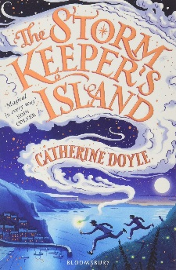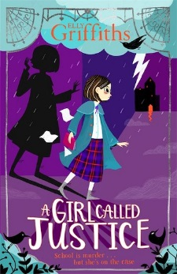

**Colm ‘Gooch’ Cooper by Donny Mahoney**

This is the story of how Colm Cooper, a boy everyone said wasn’t big enough or strong enough to wear the green and gold jersey of Kerry became one of the greatest Gaelic footballers of all time.

**Cora Staunton by Eimear Ryan**

This is the story of how Cora Staunton, a young football-mad girl became a living legend.



**Hetty Feather by Jacqueline Wilson**

Roll up, Roll Up,

for the amazing tale of

Hetty Feather

GASP

as she is abandoned as a baby

SHUDDER

At the hardship she suffers

WONDER

At her search for

Her real mother

**Race the Atlantic Wind by Oisín McGann**

Maggie McRory’s adopted home in Newfoundland has just become the setting for the world’s biggest news story. With powered flight still in its infancy, the world’s best aviators are competing to achieve what many believe to be impossible: to fly non-stop across the Atlantic Ocean. To win the £10,000 prize, the pilots must fly 1,800 miles, in cockpits open to the sky, navigating by the stars and the sun.

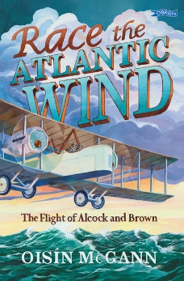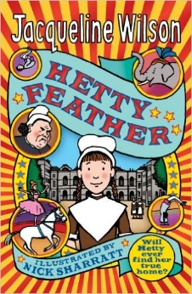



**Get Me Out Of Here! by Andy McNab and Phil Earle**

Danny’s mates are BRILLIANT – the best mates a kid could ask for.

And when they find out that their school is taking them on the most EXTREME outdoor adventure trip ever, they’re properly made up about it.

Danny’s SAS-obsessed brother is going too (NO!). And their guide is at least 132 years old (HOW!).

EVERYTHING is about to go seriously wrong … GET ME OUT OF HERE!

**Why the Whales Came by Michael Morpurgo**

*‘The Birdman puts spells on people. We mustn’t talk to him. We’re not supposed to.’*

Gracie and Daniel have been warned to stay away from the Birdman, but a message in the sand tells them the Birdman isn’t what he seems. Then they get lost in the fog and stranded on Samson Island – should they believe the Birdman’s story that the island is cursed?

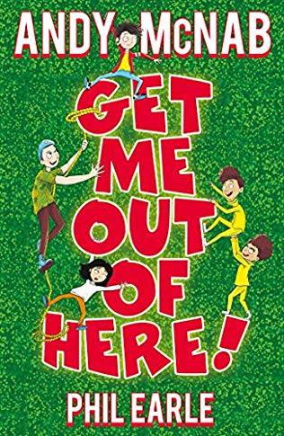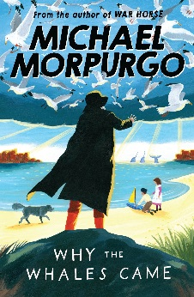

**Malamander by Thomas Taylor**

In the basement of the grand Nautilus Hotel, a mysterious girl crashes into Herbie Lemon’s room and cries, “Hide me!”. In the window of the Eerie book Dispensary, a mechanical mermonkey sits and waits. And out beyond the pier, something stirs. Could the legendary malamander have returned?

**Pog by Pádraig Kenny**

David and Penny's strange new home is surrounded by forest. It's the childhood home of their mother, who's recently died. But other creatures live here ... magical creatures, like tiny, hairy Pog. He's one of the First Folk, protecting the boundary between the worlds. As the children explore, they discover monsters slipping through from the place Pog calls 'downways'. Meanwhile, David is drawn into the woods by something darker, which insists there's a way he can bring his mother back ...

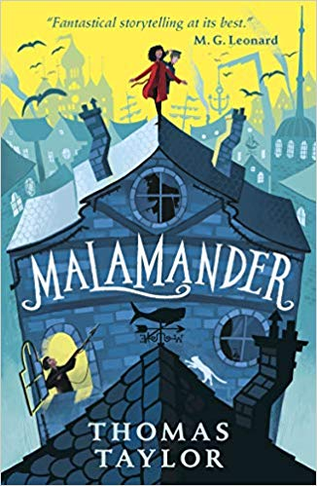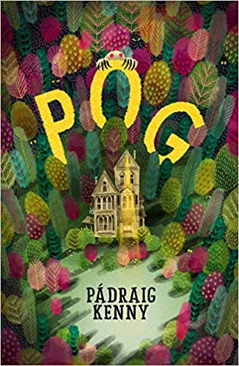

**Birthday Boy by David Baddiel**

Sam Green is really, really, really, really, really, really, really, really looking forward to his eleventh birthday. Really. He can’t wait. In fact, he wishes it was his birthday every day. So it’s quiet exciting, at first, when his birthday happens again the next morning. And again. And again. But sometimes you have to be careful what you wish for…

**Pages & Co. by Anna James**

Eleven-year-old Tilly Pages has lived above her grandparents’ bookshop ever since her mother disappeared. One day, Tilly’s favourite book characters appear in the shop, and she discovers she can follow them into their worlds through the magic of bookwandering. Can her new power solve the mystery of what happened to her mother all those years ago?

