

**Recommended Reading List 11+**

**Little Women by Louisa May Alcott**

The four Marsh sisters – Meg, Jo, Beth and Amy – live in financial hardship in New England with their mother, while their father has been drafted to fight in the Civil War. The girls embark on a series of adventures and endure a number of unexpected misfortunes – experiences that allow their personalities to emerge.

**The Umbrella Mouse by Anna Fargher**

1944, and London is under attack. The umbrella shop that young mouse Pip has called home all her life, is destroyed by a bomb, forcing her to begin a perilous quest to find a new home. But the only way to get there is by joining Noah’s Ark, a secret gang of animals fighting with the resistance in France, operating beneath the feet of human soldiers. Danger is everywhere and as the enemy closes in, Pip must risk everything to save her new friends.

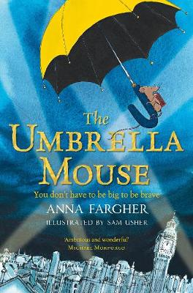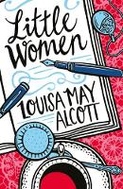

**The Wizards of Once by Cressida Cowell**

Once there was Magic, and the Magic lived in the dark forests. *Until the Warriors came...*

Xar is a Wizard boy who has no Magic, and will do anything to get it. Wish is a Warrior girl, but she owns a banned Magical Object, and she will do anything to conceal it.

In this whirlwind adventure, Xar and Wish must forget their differences if they're going to make it to the dungeons at Warrior Fort. Where something that has been sleeping for hundreds of years is stirring...

**The Train to Impossible Places by P.G. Bell**

When Suzy hears a strange noise in the middle of the night, she creeps downstairs to find a train roaring through her house. But this is no ordinary train. This is the magical delivery express for the Union of Impossible Places. Whisked on board by a troll-boy, Suzy’s world is turned upside down when she’s asked to deliver a cursed package to a fearsome sorceress. And quite suddenly, Suzy realizes the fate of the Impossible Places is in her hands.

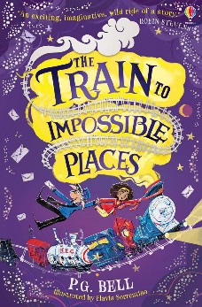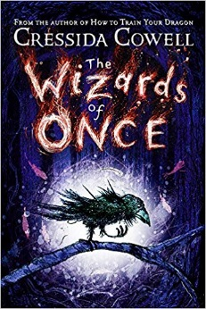

**Ronaldo by Matt and Tom Oldfield**

This is the rollercoaster story of how Ronaldo grew up to become a superstar striker for Brazil, Barcelona and Real Madrid.

**Smith by Charlotte Browne**

This is the story of how the girl from Watford refused to be held back and became an Arsenal superstar and the England women’s national team’s top scorer.

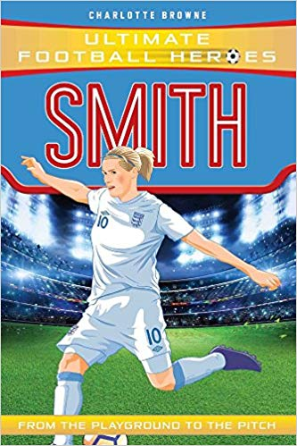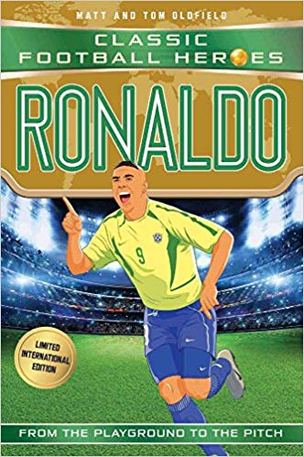



**The Wreck of the Zanzibar by Michael Morpurgo**

*We all knew what was going to happen. We’d seen it before. A ship about to founder staggers before she falls. A huge wave broke over her stern and she did not come upright again.*

Life on the Isles of Scilly in 1907 is bleak and full of hardship. Laura’s twin brother Billy, disappears and then a storm devastates everything. It seems there’s little hope … that is until the *Zanzibar* is wrecked on the island’s rocks and everything changes.

**The Story of Tracy Beaker by Jacqueline Wilson**

Once upon a time there was a little girl called Tracy Beaker…this is my own book and I can write whatever I want. The book is all about me.

Tracy is tired of living in the Dumping Ground, where she has to share everything with Weedy Peter and Awful Justine Littlewood. She longs for a real home, with a real family (at least until her movie-star mum comes to get her)

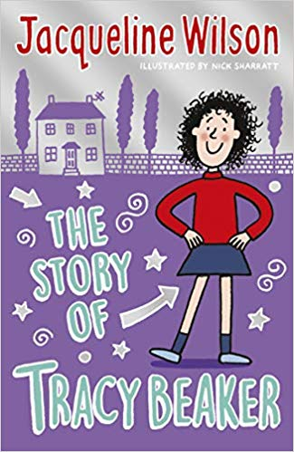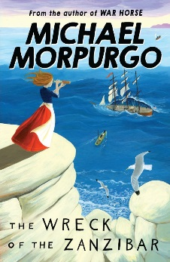

**Frostheart by Jamie Littler**

Far out in the coldest part of the monster-infested Snow Sea, Ash waits for his missing parents, with only his grumpy yeti guardian for company. But when an accident reveals that Ash has amazing powers, he’s whisked aboard the *Frostheart* – an explorer sleigh with a daring crew who needs his help. Can they help Ash master his new powers – and find his family?

**The Peculiar Peggs of Riddling Wood by Samuel J Halpin**

This is the story of a sleepy town called Suds. A place where stories fill the air of children who keep turning grey and disappearing without a trace…  
Poppy and Erasmus are certain there's something peculiar going on in Suds, and they're determined to unravel its secrets. But when they discover the answers might lie in the dark and twisting woods, can they find the courage to creep inside and solve this riddling mystery?

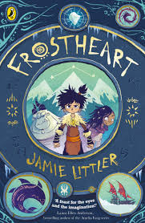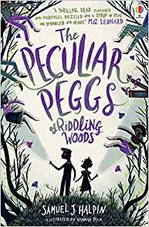

**Brilliant by Roddy Doyle**

Gloria and Rayzer must save their Uncle Ben. The black dog has got him. That’s what they heard their granny say anyway. And, she says, it’s taken Dublin’s funny bone too. Gloria and Rayzer are really brave but the black dog is scary and they can’t fight it alone. Soon Dublin’s children are helping and then the animals in Dublin Zoo and some cheeky seagulls as well.

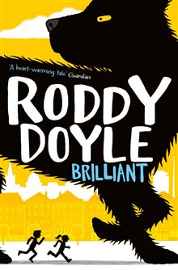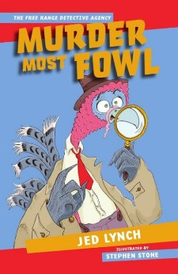

**Murder Most Fowl by Jed Lynch**

Seamus the private detective is no chicken. He’s a turkey. And after the disastrous case of the Rampaging Rhinoceros, his feathers are a little ruffled. You should never trust a cat in a fur coat, but when Ms Ermine comes slinking in with a clawful of cash, Seamus just can’t say no. Soon he’s up to his beak in a case involving a sinister snake, pigs with piercings and a meerkat called Elvis.