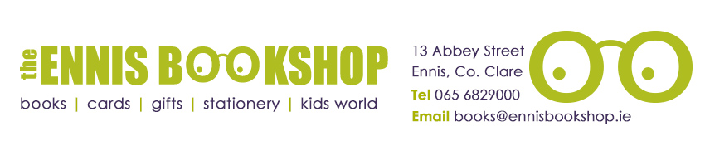

**Recommended Reading List 9+**

**The Beast of Buckingham Palace by David Walliams**

Britain.

The Future.

The Year is 2120.

Prince Alfred, a sickly boy of twelve, has never known life outside Buckingham Palace.

Evil forces are at work and he must do battle with the King of the Beasts – the Griffin…

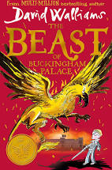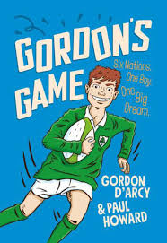

**Gordon’s Game by Gordon D’Arcy & Paul Howard**

Gordon D’Arcy is an ordinary boy, but he’s not so ordinary once he gets a rugby ball in his hands. He’s the star player for Wexford Wanderers and dreams of one day wearing the Ireland jersey. But Gordon has a wild streak that often lands him in trouble. Mum and Dad think that if he can just focus, all will be well. Then something utterly amazing happens and he gets a chance to live his biggest dream.

**The Taylor Turbochaser by David Baddiel**

Amy Taylor loves cars. Here are her favourite ones:

1. The Aston Martin DB5

2. The Mercedes 300 SL Gullwing

3. The Jaguar E-Type

4. The Ford Transit Van

Well, a Ford Transit van. Which might sound strange. You’ll have to read this book to find out why.

**The Island of Lost Horses by Stacy Gregg**

On a remote tropical island, twelve-year-old Beatriz stumbles across a wild mare with strange markings. She can’t believe that this horse is real, but soon a strong connection grows between them. Then Beatriz begins to uncover an incredible history. Centuries ago, a young girl called Felipa and her horse, Cara Blanca, were running for their lives.

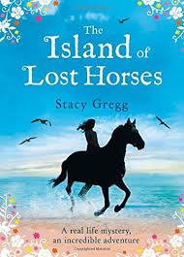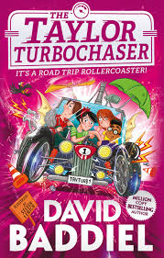

**Dairy of a Wimpy Kid: The Getaway by Jeff Kinney**

Greg Heffley and his family are getting out of town. They decide to escape to a tropical island resort for some much-needed rest and relaxation. A few days in paradise should do wonders for Greg and his frazzled family. But the Heffleys soon discover that paradise isn’t everything it’s cracked up to be. Sun poisoning, stomach troubles and venomous critters all threaten to ruin the family’s holiday.

**Opal Plumstead by Jacqueline Wilson**

Opal Plumstead is fiercely intelligent: a proud scholarship girl, with plans to go to university. Yet her dreams are shattered when her father is sent to prison, and fourteen-year-old Opal must abandon school and start work at the Fairy Glen sweet factory.

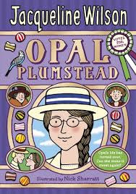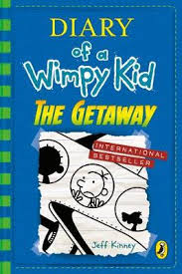



**Timmy Failure: Mistakes Were Made by Stephan Pastis**

My name is Failure. Timmy Failure. My detective agency is the best in town, perhaps the world. But success didn’t happen overnight. I had to over obstacles. I have decided to publish this history because my expertise is invaluable to anyone who has ever wanted to be a detective.

**Alice Next Door by Judi Curtin**

Poor Megan! Not only is she stuck with totally uncool parents and a little sister who is too cute for words, but now her best friend, Alice, has moved away. Now Megan has to go back to school and face the dreaded Melissa all on her own. The two friends hatch a risky plot to get back together. But can their secret plan work?

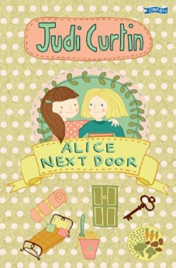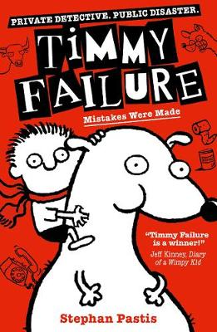

**Super Cats by Gwyneth Rees**

Tagg’s life changes forever when he discovers his parents have superpowers! Will Tagg have super strength like his dad or amazing claws like his mum? All he knows is that having superpowers will be awesome.

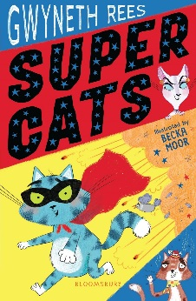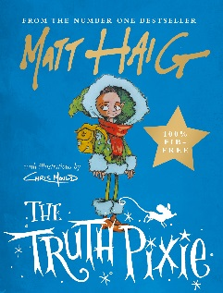

**The Truth Pixie by Matt Haig**

Wherever she is, whatever the day,

She only has one kind of thing to say.

Just as cats go miaow and cows go moo,

The Truth Pixie can only say things that are true.

**George’s Marvellous Medicine by Roald Dahl**

The rule would be this: Whatever he saw, if it was runny or powdery or gooey, it went in.

**Barry Loser is the best at football NOT! by Jim Smith**

Everyone at Barry’s school has gone football crazy, but Barry gets thrown out of the team (the Mogden Maniacs) for being completeerly rubbish. Then it turns out that his best friend Bunky is a super striker – so Barry becomes his manager. The cup final match is approaching and Bunky’s getting carried away with his football fame – can Barry keep his head in the game?

